Service Area Drive Time Tutorial and Downloading Help Document

Service Area Tutorial:
Location: S:\CHS-GIS\Streetmap\StreetMapPremium
Or on the entry page of the ArcGIS https://maps.dshs.texas.gov/portal/home/
Then click on the Service Area Drive Time Help button
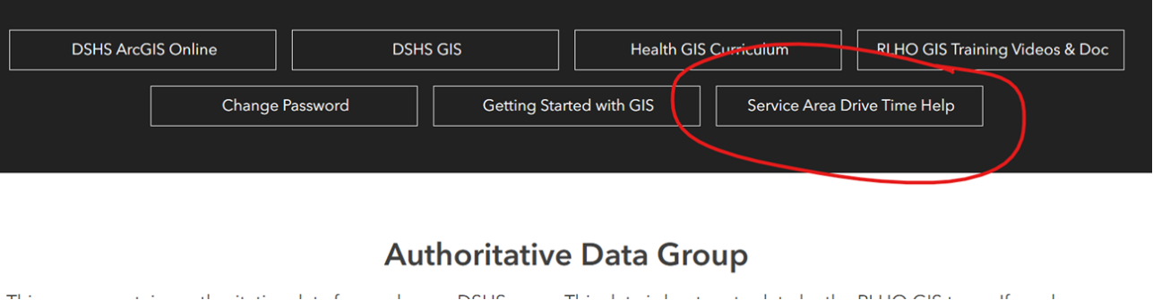
Description: This is where I would start. ESRI has a very use to use tutorial to set up and use the Service Area tool.

Service Area Setup:
Step 1: Open your ArcPro workspace and add the data points you wish to use.
Step 2: On the top right of ArcPo, go the person icon drop down arrow and choose “Manage Portals”. “Note if you are already logged in, make sure to click on “Switch to Active Portal” to switch from your arcgis online account.
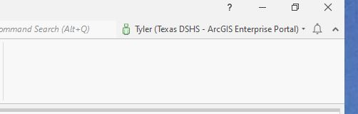

Note:
- With a Texas DSHS enterprise account, you can run the Service Area Analysis without using credits.
- You may need to “Add Portal” to your Enterprise Portal name. Here is the portal URL
- https://maps.dshs.texas.gov/portal/home
- Make sure to uncheck the sign in using browser as well
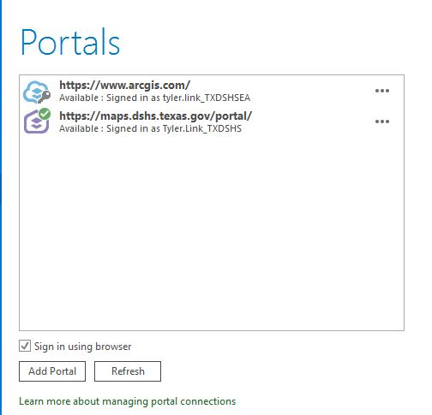

Step 3: Once you are logged in and set the Enterprise Portal as active, Go to the Analysis tab, and click the Network Analysis tab, then the Service Area Tool. 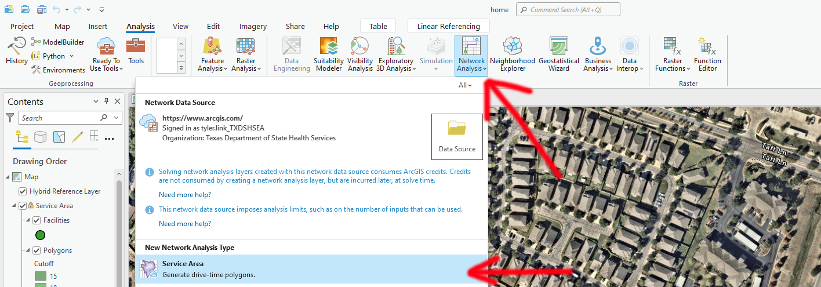

Step 4: Once selected, the first four lines will auto populate.
- The first line named “Network Data Source”, if you are logged into your ArcGIS Enterprise Portal, it will populate to https://maps.dshs.texas.gov/portal/
- The second line, “Layer Name” – will populate to Service Area 2. This you can change to whatever you would like your name will be call. I will name mine Service Area Test.
- The third line, “Travel Mode” – will populate to “Drive Time”. But there are other options to do as well, they include:
  - Driving Distance
  - Drive Time
  - Rural Driving Distance
  - Rural Driving Time
  - Trucking Distance
  - Trucking Time
  - Walking Distance
  - Walking Time
- After choosing the Travel Mode for your analysis, the next line is “Travel Direction”. You can pick “Away from Facilities” or “Towards Facilities”. Pick which one is best for your analysis.
- The next line are Cutoffs. This is where you can select the time or distance you wish to cut off. You can select a number of different times or distances. The example below has the travel time cutoffs of 5,10,15 and 30.
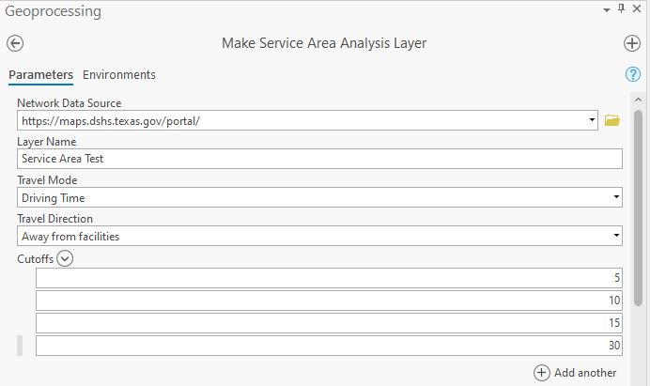

- The next major drop down contains two prompts, Time of Day and Time Zones. This will be project specific, I typically leave these blank for a general drive time analysis.
- The final dropdown is Output Geometry. Each of the following will also be project specific. I typically also leave them as the defaults shown below.
  - For Geometry at Overlaps, for more details read this
Specifies the behavior of service-area output from multiple facilities in relation to one another.
- Overlap—Individual polygons or sets of lines for each facility will be created. The polygons or lines can overlap each other. This is the default.
- Dissolve—The polygons of multiple facilities that have the same cutoff value will be joined into a single polygon. This option does not apply to line output.
- Split—An area will be assigned to the closest facility so polygons or lines do not overlap each other.
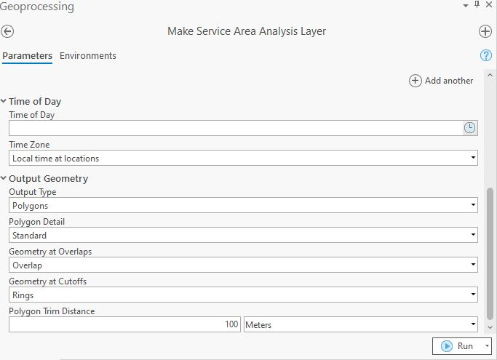

Step 5: Review your “Make Service Area Analysis Layer” to all of your project specifications to what you would like to use and click Run.

Step 6: Once ran, this will create the “Service Area Test” in your map contents window. This will also create a new tab on the top of the screen named “Service Area”.
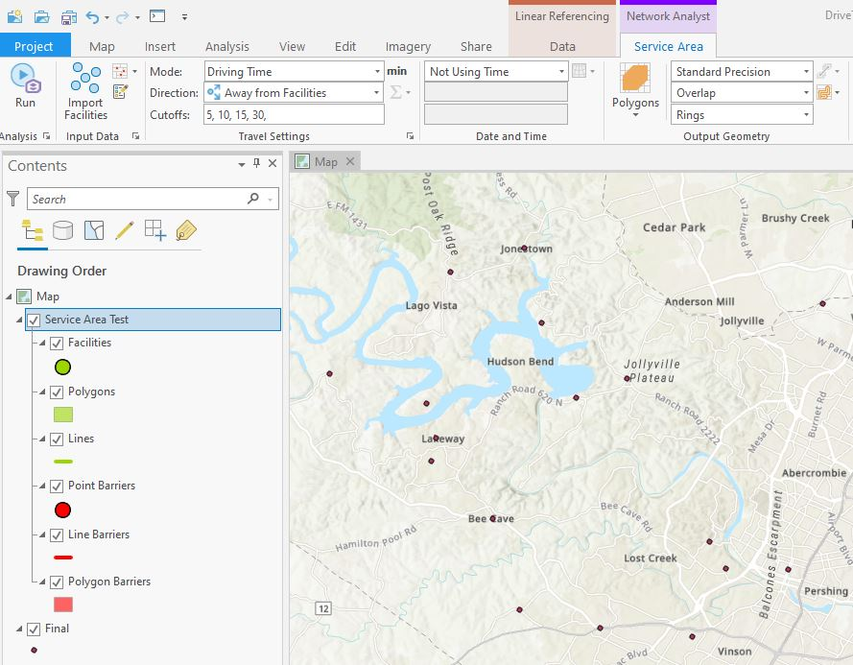

Step 7: This is where you will run the tool for your specific point data. Make sure to click on the Service Area tab. Then click on the “Import Facilities”.

Step 8: This is where you will add the locations that you are wishing to obtain drive times from. In the example below, the facilities name is called “Final” which you will add under the “Input Locations”
Note: Make sure to uncheck mark the “Append to Existing Locations”. It defaults to checking this, so make sure to uncheck this so you do not have any unwanted facilities added to your analysis by previous run drive times.
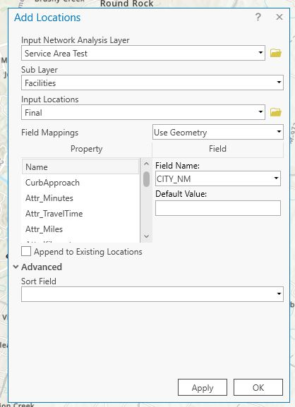

Step 9: Click Ok. This will run the tool and add your point data to the facilities.
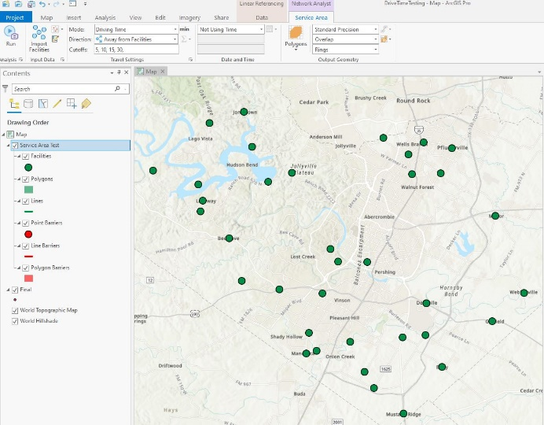
Step 10: Now you have all of your inputs ready, and push run
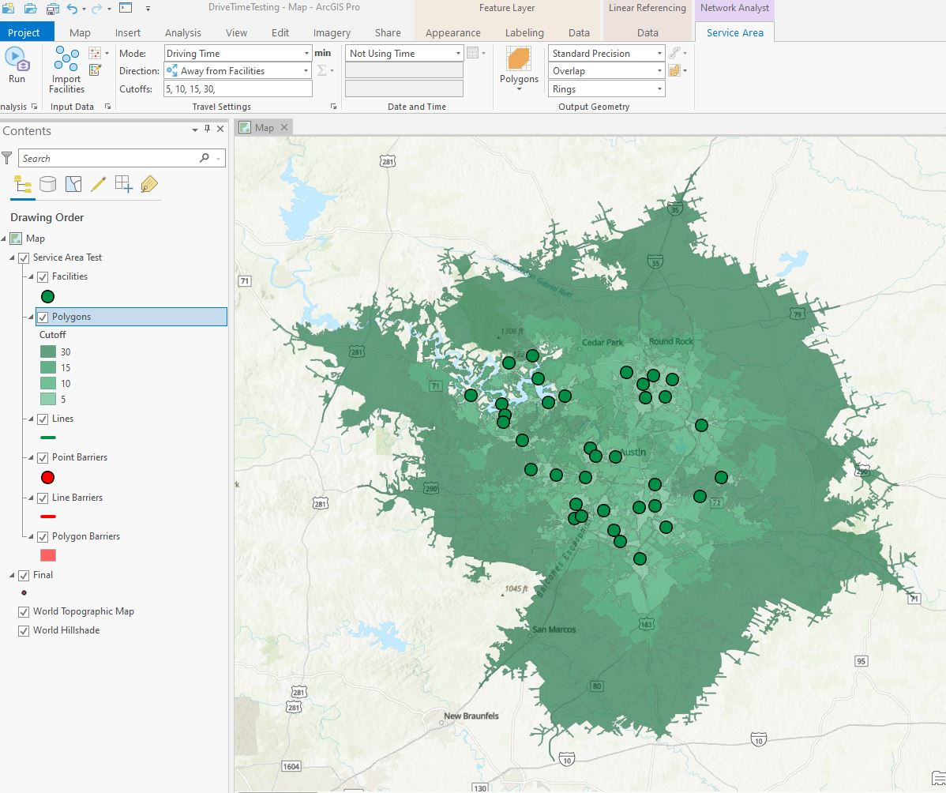

Step 11: The tool has run, before you run another drive time, make sure to export this drive time to your geodatabase.
Note: The user inputs done in Step 5, can be edited here before and after you run the tool to edit the Drive Time Tool.

If you have any questions or need further explanation, feel free to contact Tyler Link on Teams or by email Tyler.Link@dshs.texas.gov

